🔹 Types of Acceptance Testing
# Source: Chatgpt (GPT‑5 Mini) at [8/22/2025]
- User Acceptance Testing (UAT)
→ Done by end users/business representatives to validate the system meets business needs.
- Operational (Production) Acceptance Testing (OAT)
→ Checks operational readiness (backups, recovery, monitoring, security, performance, etc.).
- Contract/Regulation Acceptance Testing
→ Ensures legal, regulatory, or contract compliance.
- Compliance Acceptance Testing
→ Ensures the system adheres to internal organizational policies, standards, and industry best practices.
- Alpha Testing
→ Performed by users at the developer’s site for early feedback before beta release.
- Beta Testing
→ Performed by external users in real-world conditions before full release.
complete summary table of all Acceptance Testing types
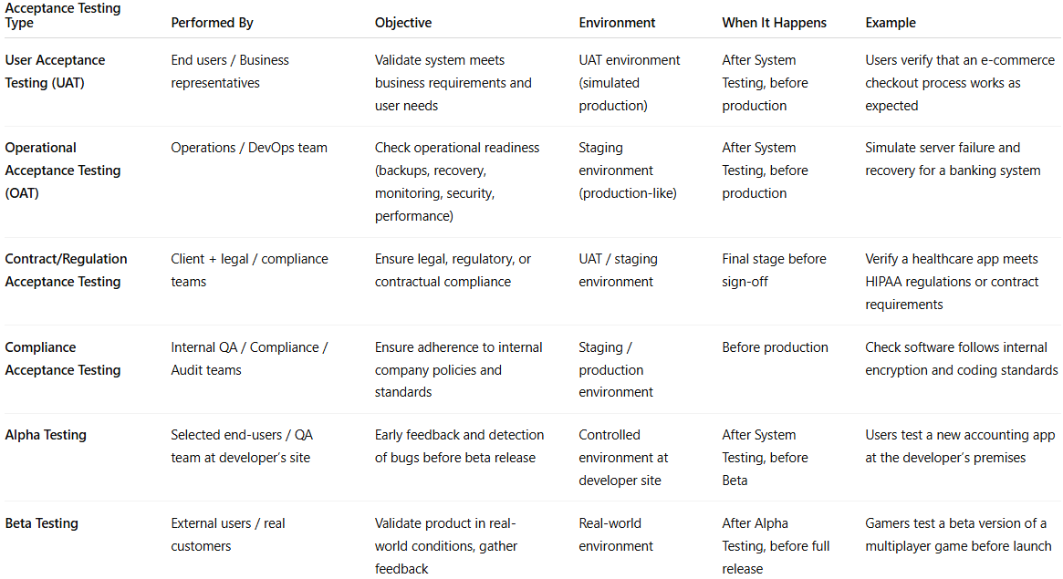

Acceptance Testing Type | Performed By | Objective | Environment | When It Happens | Example
User Acceptance Testing (UAT) | End users / Business representatives | Validate system meets business requirements and user needs | UAT environment (simulated production) | After System Testing, before production | Users verify that an e-commerce checkout process works as expected
Operational Acceptance Testing (OAT) | Operations / DevOps team | Check operational readiness (backups, recovery, monitoring, security, performance) | Staging environment (production-like) | After System Testing, before production | Simulate server failure and recovery for a banking system
Contract/Regulation Acceptance Testing | Client + legal / compliance teams | Ensure legal, regulatory, or contractual compliance | UAT / staging environment | Final stage before sign-off | Verify a healthcare app meets HIPAA regulations or contract requirements
Compliance Acceptance Testing | Internal QA / Compliance / Audit teams | Ensure adherence to internal company policies and standards | Staging / production environment | Before production | Check software follows internal encryption and coding standards
Alpha Testing | Selected end-users / QA team at developer’s site | Early feedback and detection of bugs before beta release | Controlled environment at developer site | After System Testing, before Beta | Users test a new accounting app at the developer’s premises
Beta Testing | External users / real customers | Validate product in real-world conditions, gather feedback | Real-world environment | After Alpha Testing, before full release | Gamers test a beta version of a multiplayer game before launch

